
Name: Janushiya P A
Reg No: 1924260368
Course Code: CSA0224
Course Name: C Programming

TASK 5 – ORGANISE THE PROGRAM WITH HEADER FILES AND CONDITIONAL COMPILATION
Bloom’s Level: K3 – Apply
Marks: 3

1. Aim
To organise constants and function prototypes in a header file and use conditional compilation to display debugging information only when DEBUG is enabled.

2. Algorithm
- Start.
- Create a header file containing constants, function prototypes, and include guards.
- Define the billing function in a separate C source file.
- Use #ifdef DEBUG to print intermediate values when debugging is enabled.
- Compile and execute the program with and without -DDEBUG.
- Display the output and stop.

3. Program Files
The program consists of three files:
- billing.h – contains constants, the function prototype, and include guards.
- billing.c – contains the billing function and debugging statements.
- main.c – contains the main function and displays the bill.

4. Explanation
Header files: Store constants, declarations, and function prototypes.
Include guards: #ifndef, #define, and #endif prevent a header file from being included repeatedly in the same translation unit.
Conditional compilation: #ifdef DEBUG includes debugging statements only when DEBUG is defined using -DDEBUG.
Difference between include statements:
- #include <stdio.h> is used for standard library headers.
- #include "billing.h" is used for a user-created header file and normally
- Searches the local directory first.

Code

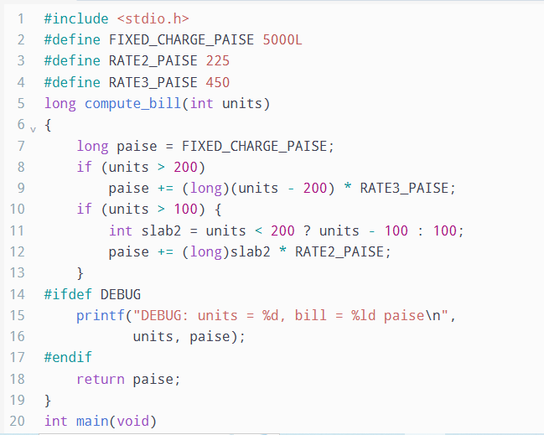

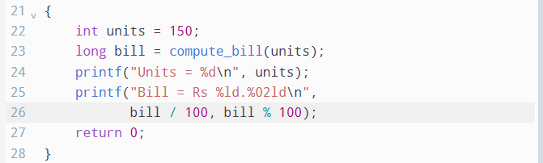

5. Output without Debugging

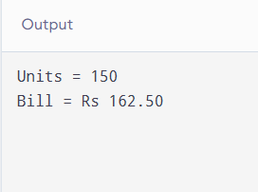

6. Output with Debugging

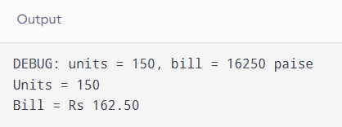

7. Complexity Analysis
The billing calculation takes O(1) time per call and O(1) auxiliary space.
With #ifdef DEBUG, debugging statements are excluded from the program when debugging is disabled, avoiding runtime checks. With if (debug), the program performs a runtime condition check, and the debug code remains compiled into the executable. The additional test takes O(1) time per call.

8. Result
The C program was organised using a header file, include guards, and conditional compilation. Debugging output is displayed when compiled with -DDEBUG and omitted when debugging is disabled.

